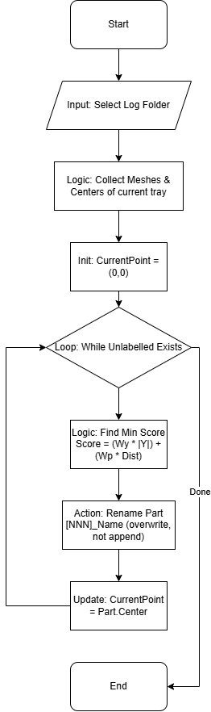
Part Rename Script (MJ)
Script Name: Part_Rename_MJ.lua

Functionality
This script reorganizes the naming convention of parts in the active tray based on their spatial location. It applies a weighted linear cost function to sequentially label parts (e.g., [001]_Name, [002]_Name) in a path that minimizes jumps between components.
Logic Flow:
- Initialization: Starts from the origin (0,0).
- Pathfinding: It iteratively finds the "next" best part to label. The "Best" part is determined by minimizing a score:
- Score = (Weight_Y * |Y_Dist|) + (Weight_Dist * Euclidean_Dist)
- Renaming: The selected part is renamed with a sequential prefix (e.g., `[001]`), and the reference point moves to this part's center for the next iteration.

User Guide (Quick Start)
- Open a tray with multiple positioned parts.
- Run the script Part_Rename_MJ.
- Select a folder for the log file.
- The script will process the parts instantly.
- Check the "Parts" list to see the new `[XXX]` prefixes.

Code Maintenance & Technical Notes
Weighted Logic: The script uses two tuning variables at the top of the file: `Weight_Y_Distance` (100.0) and `Weight_Part_Distance` (20.0). This configuration heavily penalizes Y-axis deviation (keeping the path in strips) while optimizing for general proximity.
Z-Height Note: While user notes mention Z-height logic, the current code implementation (as of 2026) calculates distances based on 2D X/Y coordinates. The `dist_sq` function ignores the Z component. If 3D sorting is required, the distance function must be updated to include `(p1.z - p2.z)^2`.
Safe Execution: The script wraps property access in `pcall` (protected call) to prevent crashes when accessing properties of potentially invalid mesh objects.

